Oswego Digital Library Development Handbook
The 2016 Development Resource for the SUNY Oswego Digital Library

Marilyn N. Ochoa
Winter-Spring 2016

TABLE OF CONTENTS

- Oswego Digital Library (http://digitallibrary.oswego.edu/)

1.1. Introduction and Handbook Purpose..............................................................................................3

1.2. Development of OswegoDL.............................................................................................................3

Special Collections...........................................................................................................................4
Oswego Institutional Repository......................................................................................................5
Homepage........................................................................................................................................7

1.3. Management of OswegoDL.............................................................................................................7

Overall Administration.....................................................................................................................8
Special Collections Collections Management..................................................................................9
Oswego IR Collections Management...............................................................................................9
Technology Support/Troubleshooting...........................................................................................10
Intermediate Management.................................................................................................. .........10

1.4. Contributor Information and Permissions.....................................................................................11

Contributor Permissions................................................................................................................11
Terms and Duration of Item Hosting.............................................................................................11
Grant of Permissions.....................................................................................................................11

1.5. Site Appearance............................................................................................................................12

1.6 Promotion and Outreach...............................................................................................................12

1.7. Statistics and Assessment.............................................................................................................13

2. Collection Groups of OswegoDL...........................................................................................................13

2.1. OswegoDL Collections List.............................................................................................................13

2.2. Special Collections.........................................................................................................................14

Past Perfect Relationship...............................................................................................................14
Past Perfect Collection Update Process.........................................................................................14
Special Collections Collections (as of Spring 2016)........................................................................16

2.3. Oswego Institutional Repository...................................................................................................17

Oswego IR Collections (as of Spring 2016).....................................................................................17
All College Resources Grouping.................................................................................................17
Student Scholarly and Creative Work (SS&CW) Grouping.........................................................18
Great Lake Review Collection, GREATLAKEREVIEW..........................................................18
Quest Program, QUEST.....................................................................................................19
Interdisciplinary Programs and Activities Center, Creative Writing Program, Creativity Lab & DigitalOZ............................... ...........................................................................20
Oswego IR Template and Default Metadata..................................................................................20

3. Next steps in OswegoDL........................................................................................................................22

3.1. General Functions and Features....................................................................................................22

3.2. Collections in Special Collection....................................................................................................22

3.3. Collections in Oswego IR...............................................................................................................22

3.4. ODL Administrator.........................................................................................................................23

3.5. Librarian Participation...................................................................................................................23

Appendices.................................................................................................................................................24

Appendix 1. First Year Development and Contributor Participants............................................................24
Appendix 2. Past Perfect to SobekCM Mapping.........................................................................................24
Appendix 3. All Collections/Existing Aggregations List as of July 15, 2016.................................................28
Appendix 4. DSpace Collection Transfer.....................................................................................................31
Appendix 5. Spring 2016 Breakout Sessions – Descriptions.......................................................................32
Appendix 6. Mid-Semester Progress Update Questions for Collection Managers.....................................34

See also
The SUNY Oswego Digital Library Penfield Library Project Plan http://oswego.sobeklibrary.com/AA00000006/00002

- Oswego Digital Library

1.1. Introduction and Handbook Purpose

The Oswego Digital Library (ODL or OswegoDL, http://digitallibrary.oswego.edu/) is a Penfield Library-developed database that contains digitized items held in the Penfield Library Special Collections along with scholarly and creative works of the State University of New York at Oswego (SUNY Oswego). The impetus for developing the resource was to better expose digitized collections and raise the visibility and awareness of work being done at SUNY Oswego. For more information about the intent of the ODL, please see the OswegoDL: The SUNY Oswego Digital Library Penfield Library Project Plan (ODL Project Plan) at http://oswego.sobeklibrary.com/AA00000006/00002.

The development of the ODL began in the winter term of 2016, with review and selection of a digital asset management systems. Penfield Library Associate Director, Marilyn N. Ochoa initiated and led the ODL development, working with the SobekCM programmer and chief information officer, Mark Sullivan (mark.v.sullivan@sobekdigital.com) and selective campus faculty, library personnel, and library interns.

While the initial soft release date was expected to be summer of 2016, with the Associate Director’s departure, this date has been postponed until a new Associate Director is hired and determines the best approach to release (see Next Steps). Note that a new version of SobekCM, version 4.10.0, was released the week of June 6. SobekCM system features and appropriate functionality are continually being assessed and updated.

This handbook documents the initial 2016 development process for the ODL along with proposed future considerations for the new Associate Director who will manage the Digital Library. This document shares information on both sections of the ODL, the Special Collections and the Oswego Institutional Repository (Oswego IR). Questions can be directed to Marilyn N. Ochoa (marilyn.ochoa@gmail.com).

1.2. Development of OswegoDL
Action items to meet the 2016 Library of Tomorrow Library Performance Drivers 3.1.1 and 5.1.3 for the Associate Director and Special Collections unit were to select a digital assets management solution and company that could meet both digital asset needs for the College and for Special Collections. As detailed in the ODL Project Plan, SobekCM was selected to host Penfield Library content.

The development site for OswegoDL is http://oswego.sobeklibrary.com/, and the Campus Technology Services created a CNAME record so that digitallibrary.oswego.edu (PROD URL) goes to http://oswego.sobeklibrary.com.

The ODL is hierarchical, with the iOswego collection as the top level collection and two additional separate parent collections, the Special Collections (collection code: SPECIALCOLLECTIONS) collection and the Institutional Repository (collection code: OSWEGOIR). Each parent collection has subcollections. Please see the Appendix 3, All Collections/Existing Aggregations List as of July 15, 2016 for general information about the collections.

Mark (also the SobekCM Host Administrator), assisted Marilyn with creating the organizational structure below based on several discussions about content available for import and for potential additions to the Oswego IR.
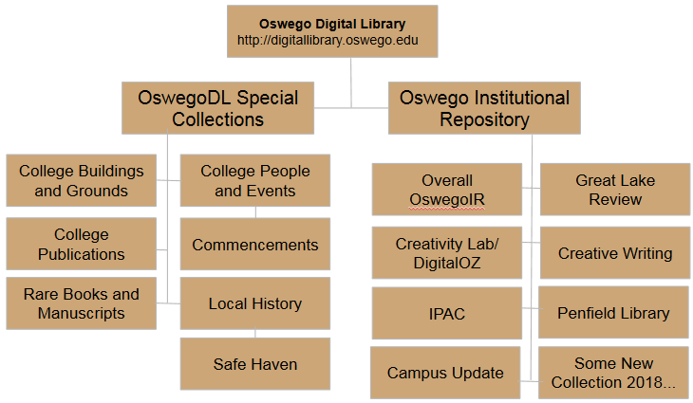

Special Collections
Mark reviewed the various sources for Special Collections content to help determine the best approach to migrate the records with the assistance of Marilyn and Nancy Johnson, Assistant Coordinator for Special Collections. These silos of Special Collections content includes records and items from:

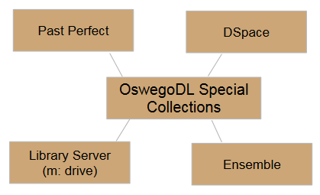
Past Perfect: cataloging software for Special Collections resources, including restricted, digitized, and non-digitized items.
Library Server: storage for original digitized materials, including multimedia content (e.g. commencement videos)
DSpace: SUNY Oswego instance of a SUNY-wide digital repository. Only the Penfield Library Newsletter and Campus Update were updated regularly.
Ensemble: SUNY Oswego-wide hosted streaming service (replacing iTunesU) to maintain Penfield Library-managed video collections (i.e. Commencement, Pan Am, Safe Haven 50th Reunion Oral Histories).

Mark mapped the libraries in the Past Perfect museum software used by Special Collections (see Appendix 2. Past Perfect to SobekCM Mapping). Each library has its own customized fields, where some like fields are not always named consistently between libraries. The mapping process by Mark enabled a fuller understanding of the records in Past Perfect, a map to standard metadata, and a step towards preparing for a possible change in cataloging system used in Special Collections. As a side note, the Past Perfect software has not had significant updates and may not be the correct software for Special Collections to continue to use (does not have a robust or easy to search public web interface).

As of 2016, Special Collections has had 29 people cataloging the 8,128 records in Past Perfect since obtaining the software in 1999. 'Catalogers' include the three Coordinators of Special Collections, three Assistant Coordinators of Special Collections (some overlap with the Coordinator), two volunteers, eight Special Collections clerks, 10 students, two graduate assistants, an intern, a librarian working on a special project, and a faculty member working on a special project. This number is quite high, and has resulted in inconsistencies in the cataloging process and interpretation for where certain items go in the four libraries within Past Perfect.

A result of the careful analysis of Past Perfect resulted in a creation of a system to update OswegoDL with new Special Collections digitized content (see Special Collections). In addition, the realization of cataloging inconsistency has prompted an ongoing, as-time-permits project for Nancy to provide quality control of older records.

Another content silo for Special Collection is the SUNY Oswego instance within DSpace (https://dspace.sunyconnect.suny.edu/handle/1951/382). The DSpace items were moved to OswegoDL on June 15, 2016, except for some Great Lake Review records (see Great Lake Review). Only some items fit into the ODL Special Collections section, including the Display to Archives and Commencement programs. Original items are also held on the library m: drive. This move is in an attempt to retire the use of DSpace and to focus use of the collection in ODL.

Only a few items from Ensemble (e.g. items from Commencement and Safe Haven collections) have been added because a full discussion about process needs to be discussed with Mark. The next step is to FTP the videos from the m: drive and recreate the records from Ensemble).

Oswego Institutional Repository
The SUNY Oswego Institutional Repository (Oswego IR) portion of the ODL includes the variety of scholarly and creative work, as well as resources developed by College units. The Oswego IR was conceived to be comprised of several layers:
- a general Oswego IR for all faculty and staff members to include their own scholarly and creative works, or that of their students.
- subcollections of categories, programs, etc. of work

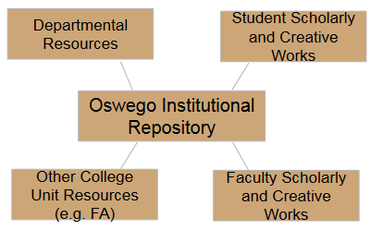
The categories of content for the Oswego IR include:
- Individual faculty and staff works
- Departmental and unit resources (e.g.
Publications Office photographs and videos)
- College committee resources
- Other related collections

Some examples of specific digital content include:
- Book chapters or journal articles
- Conference papers / presentations
- Departmental / College-related newsletters, minutes, etc.
- Books / monographs
- Technical reports, white papers, grant proposals
- Creative work (e.g. photos or digital scans)
- Audio, video, other multimedia (in any format)
- Datasets or other supplemental information of/about research
- Other digital files associated with research that a researcher wants to share with the world

Because of the rapid pace Marilyn sought to develop and release a first iteration of the ODL, it was decided that only faculty sponsored subcollections would be created, along with the library contributing content to the overall Oswego IR as time permitted. In particular, initial development was focused multiple contributors to create collections of student work, including the Quest Program, collections for Leigh Wilson of the English Department (IPAC, Creative Writing, DigitalOZ), and Great Lake Review. These were targeted because faculty members were already informed of our development (see the ODL Project Plan) and committed to doing the work of collecting and uploading materials for their individual subcollections and be part of the pilot. For the first year development and contributor participants list, please refer to the Appendix 1. First Year Development and Contributor Participants.

It should be noted the Publications Office (Jim Russell and Jim Stearns) participated in the initial planning phase that began with a series of trainings and detailed conversations about the type/volume of digital assets they held. After some discussion with Julie Fowler, she decided to hold off on using the institutional repository as a hosting service for their in-house resources or as a solution to make their public images and videos available. Issues included the number of volumes; the intent of use of images by the Office and public; the way in which those digital assets are managed; and a lack of staffing to provide analysis and processing of items.

Future considerations for Publications: how can we upload Publications Office collections? Is it possible for each item to be marked as dark archived; can SobekCM meet the functional need of sharing of some photographs with some public (not by IP address); how can a known-features update of watermarking items, in an upcoming release meet their needs?

Homepage
The homepage for the ODL as of July 15, 2016 is the fourth iteration of the homepage. In spring 2016, Emily, Danielle Minnick (a library intern) and Marilyn did usability testing to organize current collections on the homepage in a meaningful, understandable, and useful way to the SUNY Oswego community, regardless of hierarchical structure. We conducted a card sort test and later, first-click testing to make sure that users understood where they would need to click to complete certain tasks that we judged to be important. Emily describes the testing:

“We conducted card sorts with two faculty members, two staff members, and two students. One staff member was from within the library; all other participants were from outside the library. We took the names of content collections likely to be part of OswegoDL, and wrote them on slips of paper with a short blurb describing that collection on the back of the paper. Then we asked participants to sort the collections into groups that made sense to them, and give those groups names.

During the testing, we observed that in many cases participants made false assumptions about the content of various collections and didn’t check their assumptions against the content descriptions written on the back of each slip of paper. We believe this is why the content groupings that resulted from test did not make sense. In addition, several of the collections we had believed would be part of OswegoDL (and thus included in the card sort) ended up not being included after all. Ultimately, a decision was made to ignore the results of the card sort and choose a different organization method.

After we had mocked up what the OswegoDL homepage would look like, we wanted to test its design with our users. We asked 15 students each to circle where they would click if they were in one of the following situations:
- You’re interested in the history of SUNY Oswego. Are there any photos available of what it looked like when it was called Oswego Normal School?
- You’re studying terrorism, and you heard that some SUNY Oswego students died in a famous terrorist attack in the ‘80s. Are there photos from any kind of college memorial service?
- One of your classmates said she published something in the campus literary magazine, and you can read it online. Where would you find that?
- You want to know if your professor has published any scholarly work recently. Where could you find that out?

Question 1: One student located the correct place to click; three failed by clicking on Safe Haven under “Local History.”

Question 2: No student was able to locate the correct place to click.

Question 3: One student chose the Great Lake Review collection (correctly); three others chose incorrect answers, of which only one was in the “Student Scholarly and Creative Works” section of the homepage.

Question 4: Two students believed they could find that in the “College Faculty” collection; one correctly identified “Display to Archives” as the location of that information.

Because of the students’ inability to discern where various resources were stored, we redesigned the OswegoDL homepage again. This time we grouped content into fewer broad categories with explanatory text for the broad categories. We hope that this will help users in locating content in OswegoDL.”

After testing, we eliminated the use of SobekCM Thematic Headings (i.e. currently Special Collections and IR) to organize the collections. In addition, although SobekCM has a built-in HTML editor for each homepage (top level and aggregation homepages), we implemented a CSS style sheet for the top level homepage to give us more control over how the collections are displayed on the page. This allows us to create a page that is meaningful to users, despite the underlying hierarchy of collections, as below. Note that in order to make changes to the top level homepage (e.g. add text and to modify display of collections), Emily as webmaster must be contacted.

1.3. Management of OswegoDL

The Penfield Library Associate Director (the main ODL administrator) will provide the oversight and management of the ODL, as well as the policy and procedure setting for the ODL. Note that in SobekCM, this ODL administrator does not have differentiated technical permissions from other system administrators. A list of all administrators can be found in the System Admin console of OswegoDL.

Overall Administration
In the initial development, Marilyn provided the vision for the resource as articulated in the introduction of this Handbook and created appropriate goals and objectives to lead and meet that vision for all aspects of the ODL. In the initial development year, and ongoing, management and administrative responsibilities included:
- determining software, general ODL information architecture, and features/functional needs of ODL
- overseeing development of new collections
  - identifying collections/appropriate non-library content managers to collaborate with in order to develop collections
  - liaising with non-library content managers to create collection templates and to provide technical training and support for initial development
- serving as liaison on all collection and interface development between SobekCM (host administrator), non-library content managers/contributors, and library faculty partners (including webmaster and Special Collections)
- leading or delegating account creation
- assigning development tasks such as usability testing for interface design
- providing or delegating technical troubleshooting
- leading and implementing assessment, training, and promotion and outreach

A future task should be to develop a strategic plan (see Next Steps) in conjunction with the library director to articulate goals of the ODL as related to the SUNY Oswego strategic plan and mission. For first year development and Oswego IR contributor managers (aka Oswego IR collection managers), all are considered administrators for appropriate parts of the ODL).

Special Collections Collections Management
The Special Collections portion of ODL is managed by the administrator for ODL, in consultation with the Special Collections unit. This management will include, but not be limited to, delegation of tasks to ensure:
- the proper cataloging workflow changes by the unit to accurately enable automatic uploads of new digitized items into the collections
- assignment of submitting files for biannual updates to SobekCM with the assistance from the library technology unit and special collections
- reflective consideration of potential new collection development

A future task for the ODL administrator should be to assist Special Collections with recommendations on any workflow, policy, or website changes; Special Collections is set to review data collected regarding the increased visibility of content in the digital library (see Assessment).

At initial development, the Special Collections unit provided input into collection categories, but they are not prepared to liaise directly with SobekCM. Future possibilities for the management of the Special Collections collections is to have the head of Special Collections take a more active role. For this to happen, changes in the special collections unit we need to occur; for example, a dedicated head of Special Collections or digital archivist could be hired to plan digitization efforts, weighed against other priorities in Special Collections.

Oswego IR Collections Management
The ODL administrator will also be in charge of the overall management and oversight of the Oswego IR. This responsibility includes:
- provide training of SobekCM system for searching and for administration (with assistance from the SobekCM trainer)
- consult closely with collection managers to identify collection interface and item functionality and features (including display of results)
- serve as the liaison to SobekCM to create a correct template and default metadata for describing digitized items in the collection, as well as to determine if uploads of content is possible through batch FTP processing
- offer additional collection design and troubleshooting guidance/liaison support as necessary
- offer limited publicity as part of the overall ODL promotion

Any faculty member desiring to add their students’ work (e.g. as in a class or for a new program into a new collection) will need to coordinate with the ODL administrator, to define their proposed process for collection development. However, the agreement to start a collection is centered on the assumption that Oswego IR contributor collection managers are responsible for the collection in its entirety, through the processes of providing content, uploading content, and overall maintenance of the collections and interface. The collection managers are also responsible for developing the look and feel of the collection on the ODL homepage (via a thumbnail), as well as the collection homepage/banner and the result pages. They would also provide help pages, and training for contributors that their work would be made visible to the public. The basic infrastructure for a collection will be defined before the collection is added to the homepage; it is the responsibility of the collection manager to ensure ongoing development is happening if a critical mass of digital objects are not yet in the collection.

In general, when it comes to digital library development, administrators know that collections come in all sizes, and though unlikely, some may have a minimum of two objects. In terms of completion, the amount of time is not standard. In some cases, a collection may take a designated time to develop (as with grant defined collections), or years to populate. In some cases, too, collections may have ongoing contributions to it. With these digital library realities in mind, and with no particular funding or staffing designated to it, no standard deadline was assigned to the Oswego IR collection managers, but Marilyn had hoped to begin messaging about the digital library as a whole in Spring 2016.

Future work in this area of ODL management includes development of a standard MOU to keep on file for each IR subcollection to articulate such essentials as purpose of collection, estimated collection development (e.g. already curated, or ongoing curation), and the name of the collection manager with support contributors.

In addition, as the IR grows, it is important for the ODL administrator to consider strategic area/collection focus (e.g. student work) each year for steady, sustainable growth. In the future, management of the ODL may be distributed to library liaisons with faculty collection managers, although it is recommended that overall oversight is maintained by the ODL administrator.

Technology Support/Troubleshooting
The technical management of the ODL includes oversight of homepage development and troubleshooting/technology. At initial development, Marilyn was in charge of these areas. An agreement with SobekCM allowed direct email support between Marilyn and Mark. Marilyn was responsible for these aspects with limited assistance from the webmaster, Emily Mitchell. As of Summer 2016, all troubleshooting requests should be initiated through SobekCM's ticketing system, unless it is a true outage or other emergency (contact 866-981-5016 or email Mark directly). Administrators are provided individual accounts, so contact Mark to create any new administrator accounts.

To report any issues you may encounter with OswegoDL, open a ticket using http://support.sobekdigital.com or email support@sobekdigital.com (which also generates a ticket). The support ticket system sends an email to all OswegoDL System administrators (all who have system administrator rights).

Instructions for how to create a service or support request are provided on the left side of the login dashboard. The process is very simple and helps to track work going forward.

The ticket system includes a private Oswego section and a public section for tickets for the open-source repository solution.

Intermediate Management
As of July 15, 2016, a decision was made that until an Associate Director is hired, Emily Mitchell will be responsible for:
- Account Creation (until new Associate Director/ODL administrator is hired)
- Homepage design and updates
- Technical troubleshooting reporting and support
- Website placement

Oswego IR collection managers will continue to develop their collections’ look and feel during the first year. Official launch of a collection will be based on notification to the administrator of satisfactory completion as determined by the collection manager.

1.4. Contributor Information and Permissions

Special Collections contributions to the IR will be based on collections digitized by the unit (see Special Collections Group).

Oswego IR contributors are intended to be any Oswego faculty and staff. They are grouped in two categories:
- Individual Contributors
- Collection Managers and support

Although the Oswego IR will be promoted to the worldwide community for search and discovery for all to use, only faculty and staff will be encouraged by our library liaisons to submit their work to the Oswego IR. Those liaisons will provide guidance with how to submit to the collection. Students will not have specific contribution rights, but their content may be added as a part of a faculty or staff supervised collection.

Contributor Permissions
When the ODL Administrator or designee adds new IR contributors (not administrators), they are given permissions manually to confirm the IR template and OSWEGOIR default metadata. They are given the following permissions:
- "Can submit items"
- "Tracking data should be included in standard input forms"
- added to user group= IRGroup Institutional Repository Self-Submittal User Group
- added to aggregation=OSWEGOIR Collection Group

After assigned, contributors should not be given any other choice in their MyOswego interface unless they are contributing to other collections in the IR, e.g. Leigh Wilson is manager for DigitalOZ.

Terms and Duration of Item Hosting
Contributors may only include work if they are the copyright holder or licensee with the authority to grant copyright. If the license agreement states that the work may not be made publicly available until a certain date, contributors may create a record set as private. In this case, it remains invisible until the designated time (See privacy status in an individual record).

All items added to the IR will stay in the repository indefinitely, unless submitting the item is found to violate copyright, or library or digital library administrators receive a specific request by the contributor to remove the item.

Grant of Permissions
All contributors must submit a Grant of Permission before they add items to the IR. The text below has been vetted through SUNY General Counsel Ruth Booher, Special Counsel for Health Affairs, Office of General Counsel, in collaboration with Marilyn, who led development of the ODL. This was approved on May 13, 2016, and a copy is housed in the OswegoDL at http://oswego.sobeklibrary.com/AA00000205/00001.

I, ____________________________________, as copyright holder or licensee with the authority to grant copyright to the title identified below hereby grant permission to Penfield Library, State University of New York at Oswego, acting on behalf of the State University of New York, to digitize, distribute and archive this title for nonprofit, educational purposes via the Internet or successive technologies. This is a non-exclusive grant of permissions for on-line and off-line use for an indefinite term. Off-line uses shall be either (i) for educational uses consistent with the terms of U.S. copyright legislation's "fair use" provisions, or (ii) by the Penfield Library, State University of New York at Oswego consistent with the maintenance and preservation of an archival copy. Digitization allows the Penfield Library, State University of New York at Oswego to generate image- and text-based versions as appropriate and to provide and enhance access using search software. This grant of permissions does not permit the use of digitized versions for commercial use or profit by individuals other than the copyright holder. The copyright holders retain all other rights in the copyrighted work.

I understand that the State University of New York at Oswego and State University of New York are not responsible, and cannot be held liable, for any violations of United States copyright law by users of the Penfield Library, State University of New York at Oswego.

1.5. Site Appearance

The OswegoDL homepage provides information about the purpose of the OswegoDL and fast access links to major collections in its two parts. Emily must make any changes on the homepage including how collection buttons appear on the page because of CSS use on the homepage. Individual collection homepages (e.g. Oswego IR collections/subcollections) are managed by the collection manager. CSS can be used in lieu of the WYSIWYG feature for managing those pages. Please see 1.2 for more information about homepage development.

The ability to use Web Content pages is useful for developing localized help pages for the OswegoDL and its collections/subcollections. These are considered child pages. At this time, only "contributing" and "grants" pages are available and intended to be associated with ALL and iOswego aggregations.

1.6 Promotion and Outreach
Because the ODL is in the initial development phase, very little promotion or outreach has been done to share the new resource with the Oswego community. The limited outreach, included the following:

- Three sessions provided to Oswego faculty and staff at the Spring 2016 breakout sessions arranged by the Center for Excellence in Learning and Teaching. The intent was to share purpose of the overall ODL; to have pilot collection managers introduce their collections; and to provide a hands-on session for contributing new content. Descriptions are listed in Appendix, Spring 2016 Breakout Sessions - Descriptions, and video recordings of those sessions are in the Oswego IR.
  - To Collect, Preserve, and Disseminate: The Oswego Digital Library
  - Exploring the SUNY Oswego Institutional Repository: A Contributors' Panel
  - Contributing to the SUNY Oswego Institutional Repository
- An FAQ for the Quest Program (see Contribute to the Quest Collection in the Oswego Digital Library at http://oswego.sobeklibrary.com/SUOS000789/00001).
- Training sessions provided to librarians in order to give them information on what ODL entails, with possible future directions for the next academic year. It was recommended that the academic year 2016 to 2017 primarily be to finalize (populate and promote pilot collections) the Oswego IR collections; to determine the appropriate workflow needed for collection development and management; and to assess the use of the collections. The PowerPoint is available at http://oswego.sobeklibrary.com/AA00000216/00001.

1.7. Statistics and Assessment
The SobekCM software is equipped to capture statistics of collections (see http://digitallibrary.oswego.edu/l/stats/usage). In addition, from the administrative view, statistics include:
- Collections by Date
- Item Views by Date
- Collection History

Individual contributors can set up alerts that that the system automatically emails them every month with their stats.

Assessment for the Special Collections collections will be done after the first year to determine if changes need to be made to Special Collections website pages that refer to online content, etc. A decision was made on July 5, 2016 to add tracking of OswegoDL related requests in Gimlet. This category was created by the unit to track those requests for assistance in using the digital item or for print requests (as referred from OswegoDL).

The commitment of time and people resources to complete the process of Oswego IR collection development can be extreme, so careful analysis of that development should be done. Assessment of Oswego IR after this first year will help determine appropriate revision of workflows, etc. as necessary to ensure sustainable growth and success of the Oswego IR. Another area to consider for evaluation of OswegoDL is number of contributors for the Oswego IR.

Also, this assessment of collection development and collaborations can be useful in determining what new types of promotion to consider, including copyright training, as appropriate.

2. Collection Groups of OswegoDL

2.1. OswegoDL Collections List
The final list of first year OswegoDL collections is available at https://docs.google.com/spreadsheets/d/1-3lcVDhpcw-92LSLs-H0CDDiLWMxJGoRYfQNVtbQaKI/edit#gid=0, and also is at Appendix 3, All Collections/Existing Aggregations List as of July 15, 2016. The appendix includes development notes.

2.2. Special Collections

Past Perfect Relationship
Mapping of the Special Collections Past Perfect Museum Software was done in Winter 2016 by Mark, to determine the best way to migrate that content. Nancy provided analysis of the records with digital content, and several worksheets are in the spreadsheet at
https://docs.google.com/spreadsheets/d/1tXH1nXVQmZ2egVTPop95ziVTXMQe38QMcN-ca7OYdr8/edit#gid=92641370. This spreadsheet shows the progress of analyses, which includes the original list of digital items to potential collections and subcollections, as well as collections with Code and Past Perfect ObjectID numbers. Copyrighted materials will be restricted in the Past Perfect museum software used and excluded from the ODL.

The Past Perfect ObjectID are included as accession numbers in OswegoDL, and they have been properly mapped to identified appropriate collections (see the Collection Ranges tab).

Since January 2016, Nancy has been applying collection codes to items, and is the only change in the workflow for Special Collections to add digitized content to OswegoDL. Collection codes are added to the field Collection Code in Past Perfect for:
- newly added records in Past Perfect that has a digital object attached
- modified records in Past Perfect that now have a digital object attached

The collection codes are the same codes used in OswegoDL.

Note that the identification of collection items resulted in the need to change the collection codes for items identified in the Collection Ranges tab. Marilyn requested that Nancy only make changes as part of regular quality control practices, and as time permits.

Past Perfect Collection Update Process
Adding new or modified records with digital content from Past Perfect is planned for twice a year when the usual backup of Past Perfect occurs. The zipped files will be sent to Mark at mark.v.sullivan@sobekdigital.com.

The update essentially imports all ObjectID numbers in Past Perfect that are:
- Identified in the original Collection Ranges tab (as above)
- have a collection code in the Collection Code field

In a new update, any record that already exists in ODL will be overridden. This is not usually a problem, except if changes were manually made in ODL to the record that is already in Past Perfect. Special Collections has been advised only to make changes in Past Perfect.

The following directions were developed by Natalie Sturr on March 23, 2016 for Obtaining and Zipping Past Perfect Files to SobekCM.
A. Be sure the latest information is on drive P:
- When the Past Perfect server is booted up for the day, a backup is automatically taken
- At 10:00am each day a backup is taken – provide the server is booted up
- To run the backup manually:
- Log into the Past Perfect server
- Click the Windows icon
- In the box to ‘Search programs and files’, input: backup.cmd
o Press <Enter>
· When you see backup.cmd listed under Programs, click: backup.cmd
o The program will take several seconds to run
o When it is complete, the window will close

B. Create a folder of files on your desktop (or somewhere on your computer)
- Create a folder on your desktop or some place on your computer
- Suggested name for the folder: PastPerfect_bkup_mm-dd-yyyy
- Substitute today’s date for mm-dd-yyyy
- On drive P:, move to the folder: backups / speccoll / server / pp5 / Data
- Copy the following files from P: into the new PastPerfect_bkup_date folder:
- ARCHIVES.dbf  - CONDRPT.dbf  - CONTLIST.dbf  - LIBRARY.dbf  - LINKS.dbf | - location.dbf  - media.dbf  - OBJECTS.dbf  - PEOPLE.dbf  - PHOTOS.dbf

C. Zip the PastPerfect_bkup_date folder
- Right-click the PastPerfect_bkup_date folder that is on your desktop (or elsewhere on your computer)
- Select Send to Select Compressed (zipped) folder
- A new file will be created with the name: PastPerfect_bkup_date.zip
The zip file will be in the same locate as the PastPerfect_bkup_date folder
- Email the zip file to SobekCM (or Mark directly)

Special Collections Collections (as of Spring 2016)

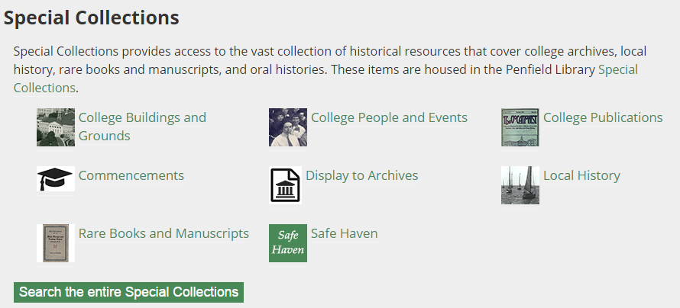

The Special Collections collections, SPECIALCOLLECTIONS (collection code in SobekCM), include:
- College Buildings and Grounds, BGR (includes Oswego Normal School, ONS is the Past Perfect code)
- College People & Events, CAP
  - subcollection: Commencements, COMMENCEMENTS (programs from 1988 to present were imported from DSpace and recordings of the ceremonies were taken from Ensemble.)
  - subcollection: Pan Am Facets, PANAM (not active)
  - subcollection: Faculty Portrait Exhibit, FPE (digitized by Special Collections in June 2016, after removal of physical collection on June 13, 2016.)
  - Other Past Perfect Codes:
    - IGP – Individual / Group Photographs
    - CPP – College Presidents Photographs
- College Publications, CPUB (includes Publications)
  - subcollection: Display to Archives, DISPLAY2ARCHIVES
- Local History, LOCALHISTORY (includes Oswego County)
  - subcollection: Safe Haven, SAFEHAVEN (includes oral histories on audio, video and transcripts)
  - Other Past Perfect Codes:
    - OCP – Oswego County Photographs
- Rare Books and Manuscripts, MANUSCRIPTS
  - MSS - Manuscripts

Special Collections has decided to retain all output features at the item level. It was determined that because the outputs had OswegoDL branding and information, unauthorized use would not generally be possible.

Only the facets of Language and Publisher were removed from all collections.

2.3. Oswego Institutional Repository

Oswego IR Collections (as of Spring 2016)

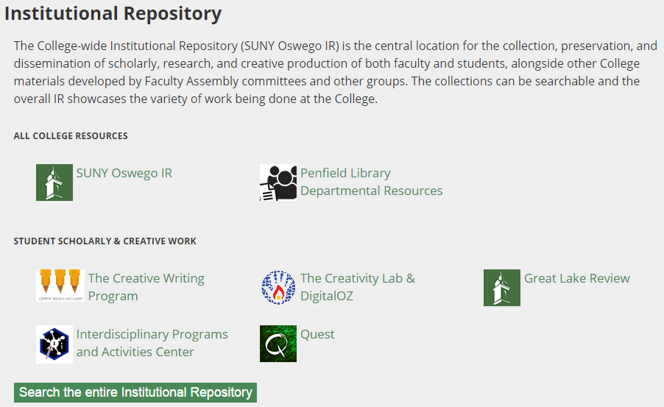

The Groupings can be modified as needed; please see Emily for details.

All College Resources Grouping
SUNY Oswego IR, OSWEGOIR is the overall group for non-Special Collections content. Although it appears on the homepage to be a collection on the same level as the Penfield Library Departmental Resources collection, it is the top level in the IR and all materials in the IR are added to it.
This is where all individual submissions are added, including the Open SUNY Textbooks. Because we only have one, it is integrated into the Oswego IR. Marilyn contacted the Open SUNY textbook team, and the editor and project manager (Allison Brown (browna@geneseo.edu) and Kate Pitcher (pitcher@geneseo.edu)) were eager to have textbooks authored or edited by an Oswego affiliate made available in the OswegoDL as well. They provided copies of both the PDF and .epub files for upload. The current example is Kristen Munger’s textbook, Steps to Success: Crossing the Bridge Between Literacy Research and Practice (http://oswego.sobeklibrary.com/AA00000199/00001).

Other collections/considerations include:
  - subcollection: Penfield Library Departmental Resources, PENFIELDLIBRARY Currently this is the only visible collection on the homepage, and it has a subcollection Penfield Library Newsletter, LIBRARYNEWSLETTER. Selected library resources have been added in training sessions and by the associate director as time permitted. It is recommended that all Department resources (found at http://oswego.edu/library_department/) continue to be added as time permits and perhaps with assistance from the librarians who have accounts and are trained in contributing to ODL.
  - subcollection: Campus Update, CAMPUSUPDATE (single serial with 233 items). Campus Update was originally in DSpace and imported to the collection by Elizabeth Young. When migrating to OswegoDL, Marilyn chose to make these a single serial so that it appears as one title with multiple items. 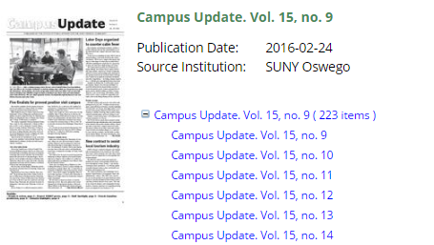

Future considerations: The new associate director needs to determine whether or not Beth will continue to update the Campus Update in the IR.

Potential/Related subcollections:
Palladium Times was digitized by the Northern New York Library Network, through a collaborative effort by Penfield Library and the local public library in academic year 2015-2016. Adding a hyperlink to that collections might be useful on the local history section of the ODL.

Artswego’s John Shaffer has expressed interest in collection building.

Student Scholarly and Creative Work (SS&CW) Grouping
Great Lake Review Collection, GREATLAKEREVIEW
The Great Lakes Review (GLR) collection that was initially in the DSpace repository as administered by the overall SUNY system. Because of Marilyn’s emphasis to move from silo collections to a single digital library repository, the student publication was migrated to SobekCM through a file import (as facilitated with the help of Emily as DSpace administrator). Unfortunately, several issues of the 62 total issues in DSpace were not originally scanned as individual pages. Instead, a single scanned page image has two pages, and thus the use of page turner viewing of SobekCM will not properly work. Mark has not yet imported those until he can split the pages apart using specialized software. No timeline has been decided for completion of this processing.

At the initial development phase, Danielle Minnick, the GLR managing editor for that Spring, served as an intern for the library; she worked with Mark and Marilyn to identify the page viewer option as the best way to present GLR for both the interface and result pages. This resulted in the GLR collection having each issue display as an individual item in the GLR. In doing so, each individual item will be retrieved when the serial is searched within the overall ODL, the Oswego IR, or the collection itself.

The progress sheet regarding making the publication more accessible, including adding table of contents information within the system for several issues and other metadata, is at Progress Sheet: GLR/Safe Haven Inputs, at https://docs.google.com/spreadsheets/d/1tnvH81aCcU9lnRHhQGwMeTFsBdA_1Mt1oeA8pSHUsJY/edit#gid=0.

Danielle worked on a time-consuming effort to add table of contents (TOC), but only four issues were completed before she graduated. After Spring term ended, Molly Bacon served as an intern, and Marilyn had Molly add the contributor and editorial board names to the Notes/Scope/Content section of the record instead of to the TOC. This process is faster, and the names are searchable. Because adding TOC is an onerous process, TOC creation will happen as time permits. Capturing the information as Marilyn had Molly do it will make the collection more accessible with less effort. Do note that because of inconsistency in the way the original pages were created (e.g. formatting inconsistencies including use of tables versus tabs to separate the name of the author from the name of the creative work), this process is still time consuming.

In June, Marilyn met with Laura Donnelly, the GLR faculty advisor, by phone. Laura is interested in digital work, and has indicated a willingness to add an assignment regarding the GLR Collection in her fall course. Effort needs to be taken to provide Laura some training and to add her as an administrator for the GLR. Natalie Sturr had managed to GLR in DSpace and has included a few issues into the collection in the new Oswego IR. Once Laura has been trained, she or her students should be able to take on this task, which is done biannually. Future work includes programmer addition of issues (Mark already has them in his system), and adding contributor names to the metadata. Also, quality control of and adding missing issues to OswegoDL should be completed by Mark.

Quest Program, QUEST
The Quest collection includes contributions of Quest Day participants, and was originally supported by Roger Taylor, former chair of the quest program and marketing for the College’s Scholarly and Creative Activities Committee. Over time, Denise Dirienzo and Rachel Carbonaro began to work on the collection project. The collection was created to meet goals including serving as the official and permanent record of program of individual presentations and the program at Quest; a permanent URL will be created. Digitized programs from DSpace were added to the collection by Mark, and the 2016 participant spreadsheet with abstracts were uploaded by Mark as well. No digital objects were added to the 2016 list because discussion about process occurred too closely to the Quest date.

The Quest collaborators, Emily, and Marilyn discussed use of how to collect presentation information along with the actual digital content. The use of their current survey software and attachment feature was discussed. How to relay information about copyright was also considered.

Because of recently changes in Quest personnel, a review of the collection goals and process with new Quest program director should occur this year.

Interdisciplinary Programs and Activities Center, Creative Writing Program, Creativity Lab & DigitalOZ
These collections are being administered by Leigh Wilson, English Department, and also maintained by Stephanie Prichard (although she is mostly focused on the Creativity Lab, as described in the panel session during the spring 2016 breakout).

These collections rely on contributions of students creating digital projects as final class assignments. Although work on developing the interface began in Spring 2016, the contributions were not in hand until after the Spring 2016 semester ended. It was anticipated that uploading materials would occur in the summertime. Due to faculty schedules, limited work was done in uploading these videos and other creative projects. A meeting to discuss collection progress is recommended.

Oswego IR Template and Default Metadata
A common collection template is used for Oswego Institutional Repository collection group. Some subcollections have individual templates with unique fields. One issue that all SS&CW collections have that often works will have multiple authors, representing different departments, and have a single sponsor. Because an authority file is not yet available, at this time, the Department is associated with the sponsor and not the creator.

One request in the queue is how to deal with these Affiliations (department, advisor, etc.), and associating them with multiple authors. Mark has indicated that once the authority file programming is completed, departments can be paired with creators (as necessary) instead of the single sponsor of the work.

At this time, the only required fields are the Title and Resource Type. As with many other digital libraries, the “cataloging” of digital items is not always standard. Work needs to be done to better define what each field means for public use and to perhaps develop a local standard for cataloging within the OswegoDL. Training of collection managers should help to create consistency in formatting, as well as creating local help pages for use within the system itself.

Default metadata was developed so that standard text would not have to be inputted by contributors each time. The default metadata for collections are similar to the following for general IR items, and often is for fields related to how the item was contributed. For example, we currently use the following default metadata:

Source Institution: SUNY Oswego Institution ( iOSWEGO )
Holding Location: SUNY Oswego Institution ( iOSWEGO )
Rights Management: All rights reserved by the source institution.
Acquisition: Collected for the SUNY Oswego Oswego Institutional Repository Self-Submittal tool. Submitted by Marilyn Ochoa.

Note that in some areas, the default metadata needs to be cleaned up. This is due to Marilyn using a University of Florida template while in development.

The standard template for all SS&CW collections follows.

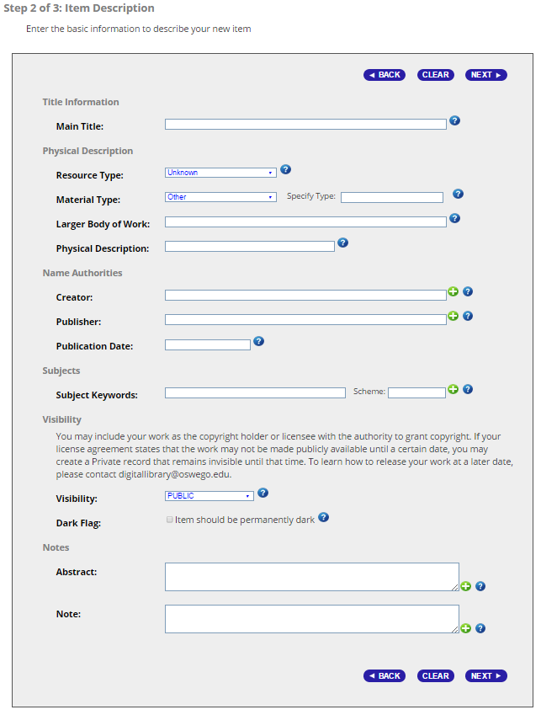
3. Next steps in OswegoDL

3.1. General Functions and Features
- Decide placement on Penfield Library website
- Develop help resources: Searching the OswegoDL, Navigating the OswegoDL, Citing the OswegoDL, Building a New Oswego IR Collection, and metadata field guide to provide formatting of data
- SobekCM updates:
  - Watermarking ©State University of New York at Oswego, Authority file (especially useful for multi-author items)
  - Authority file
  - EAD Support. We hope to include all items in the Archives Library of Past Perfect that are in container lists. Once the new update is complete, these items will be added to the Rare Books and Manuscripts Collection and tested.
- Ongoing:
  - Break and fix errant issues within the interface
  - Clean up default metadata that applied University of Florida template in development
  - Refine result pages (e.g. facets)

3.2. Collections in Special Collections
- Discuss Ensemble collection items upload with Mark Sullivan: affects Pan Am, Commencement videos, Safe Haven Oral History videos. Progress sheet/record of current work on manual uploads is found at https://docs.google.com/spreadsheets/d/1tnvH81aCcU9lnRHhQGwMeTFsBdA_1Mt1oeA8pSHUsJY/edit#gid=0). Related topics:
  - Change MV4 encoding to MP4, since that is the standard moving forward (along with OGG and WEBM). Mark will batch process the limited number of videos.
  - Past Perfect commencement videos records need to be cleaned up; many have broken links. Nancy compared the dates of the videos in Past Perfect with the ones on Special Collections website. All the Past Perfect videos are on the website. Actually there are more on the website. Nancy recommends deleting the links from Past Perfect records and Marilyn agrees since they will be batch migrated (hopefully) from Ensemble and the m: drive with assistance from Mark. Once migration is done, consider enriching OswegoDL records with Past Perfect information,, keeping in mind the override issue.
- Decide if replacing the Special Collections Safe Haven website on ODL is preferable
- Consider adding Display to Archives first pages of articles submitted (copyright and workflow issues need to be addressed)
- Track and assess usage of OswegoDL and impacts on reference and printing

3.3. Collections in Oswego IR
- Emphasize individual faculty and staff submissions (with assistance from librarians and promotional materials), as opposed to full collection building
- Encourage collection developers to create training materials for using their collections
- Create records of Library Department resources that we easily have access to and to serve as a model for other units who may wish to include their administrative works into the IR
- Assess collection development in collaboration with current collection content builders (e.g. Quest, DigitalOZ, etc.)
- Make changes if necessary to the development workflow
- Develop collection criteria and priority checklist. Note that collection building involves multiple steps including determining content focus, workflows and customized templates, homepage/banner look and feel, copyright permissions training. This work will be done with the content provider in collaboration with the library liaison, and the help of the SobekCM programmer and Library Webmaster.
- Draft and distribute a MOU for collection managers to complete.
- Collection considerations:
  - Campus Update- Need to contact Publications to request full PDF for Campus Updates as the current submissions sent to Special Collections are only PDFs of the first page and the hyperlinks do not save.
  - Faculty Assembly (See Nancy for information about Special Collections records of these print files)
  - Digital Humanities Courses (perhaps pursued with faculty through library liaisons)
  - Artswego (pursue discussion with John Shaffer who has already expressed an interest)

3.4. ODL Administrator
- Learn OswegoDL
- Determine date for official launch of full ODL or individual sections. Note that more work should be done on the Oswego IR collections before release, but Special Collections collections may be released immediately (updates biannually).
- Craft promotional material.
- Guide librarians on how to participate
- Consider adding OswegoDL to the Library Catalog for additional discoverability
- Determine types of training to consider, including copyright training
- Scan Sheldon Death Mask and use it for promotion of the OswegoDL

3.5. Librarian Participation
- Include works to Oswego IR
- Review resources in OswegoDL to understand the database and its parts
- Emphasize individual faculty and staff submissions in department meeting to help build the database before official launch

Appendices

Appendix 1. First year development and contributor participants

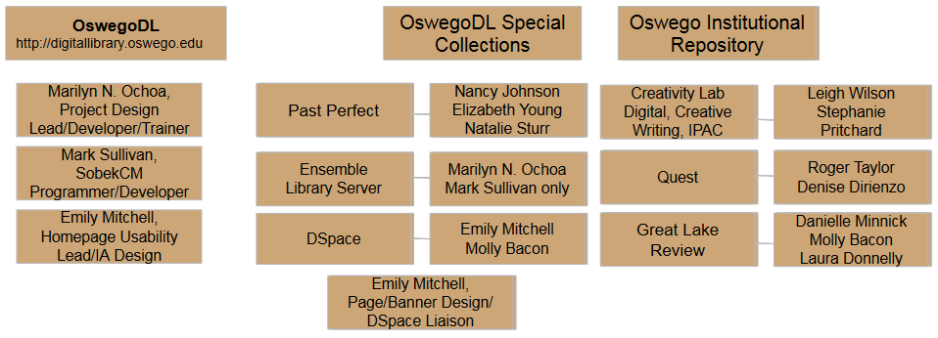
Note that CTS is not fully participating, but Dan Laird has been set as admin due to faculty IT support role. Sean Moriarty has not committed any funds or provided technical support, but was part of vendor review process.

Appendix 2. Past Perfect to SobekCM Mapping

TOPIC | FIELD_NAME | SOBEKCM FIELD | ARCHIVES | LIBRARY | OBJECTS | PHOTOS
Author Added Entry | AUTHORX | Creator (additional) |  | X
Call# | CALLNO | Identifier |  | X
Caption | CAPTION | General Note (Caption: 'xxx') | X | X | X | X
Classification | CLASSES | Classification ( like Identifier ) | X | X | X
Collection | COLLECTION | Mapped to SobekCM Subcollections | X | X | X | X
Condition | CONDITION | ACTION NOTE |  | X | OMIT | OMIT
Author, Artist, Photographer | CREATOR | Creator |  | X | X | X
Date | DATE | CREATION DATE for OBJECTS and PHOTOS. PUBLICATION DATE for library | X | X | X | X
Summary / Description | DESCRIP | ABSTRACT / SUMMARY NOTE | X | X | X | X
Year Range from | EARLYDATE | Use as PUBLICATION DATE, if pub date is not present | X | X | X | X
Edition | EDITION | EDITION |  | X
Event | EVENT | Special logic. Map to Conference Author, if no author. If dissertation, try to extract degree. Ignore "Dallas" | X | X | X | X
Category | GPARENT | SUBJECT GENRE (combined with SubCategory) with source of nmc. Leaving out "10: Unclassifiable Artifacts" | X | X | X
Image (picture) | imagefile | n/a |  | X | OMIT | X
Number of Images | IMAGENO | (compare to images) | X | X | X | X
ISBN | ISBN | IDENTIFIER Type=ISBN |  | X
ISSN | ISSN | IDENTIFIER Type=ISSN |  | X
Language | LANGUAGE | LANGUAGE | X | X
Year Range to | LATEDATE | Use as PUBLICATION DATE, if pub date is not present | X | X | X | X
LCCN | LCCN | IDENTIFIER TYPE=LCCN |  | X
Object ID | OBJECTID | ACCESSION NUMBER | X | X | X | X
Object Name | OBJNAME | GENRE | X | X | X | X
Other # | OTHERNO | Compare to CallNum, add as IDENTIFIER if different | X | X |  | OMIT
Subcategory | PARENT | SUBJECT GENRE (combined with Category) with source of nmc. Leaving out "10: Unclassifiable Artifacts" | X | X | X
People | PEOPLE | NAME AS SUBJECT | X | X | X | X
Phys Desc | PHYSDESC | PHYSICAL DESCRIPTION |  | X
Publisher | PUBLISHER | PUBLISHER | X | X
Pub Place | PUBPLACE | PUBLICATION PLACE | X | X
Series | SERIES | SERIES TITLE | X | X
Spine Label | SPINELBL | (Going to ignore, since a copy of data saved elsewhere) |  | X
Search Terms | STERMS | SUBJECTS | X | X | X | X
Subjects | SUBJECTS | SUBJECT | X | X | X | X
Title | TITLE | TITLE | X | X | X | X
Title Added Entry | TITLEX | ADDITIONAL TITLE |  | X
Dates | UDF22 | (None in library collection) |  | X |  | X
Admin/Biographical History | ADMIN |  | X
Area / Region | AREA |  | X
Dates of Accumulation | DATEACCUM |  | X
Dates of Creation | DATECREATE |  | X
Diameter (IN) | DIAMETERIN | Measurements |  |  | X
Dimension Details | DIMNOTES | Measurements |  |  |  | X
East Longitude | ELONGITUDE | Coordiantes | X
Extent of Description | EXTENT |  | X
Finding Aids | FINDAID |  | X
Frame Description | FRAME | Notes |  |  | X | X
Frame Size | FRAMESIZE | Notes |  |  | X
Heifht (ft) | HEIGHTFT | Measurement |  |  | X
Height (in) | HEIGHTIN | Measurement |  |  | X
Image Size | IMAGESIZE | Measurement |  |  | X
Insets | INSETS |  | X
Interviewer | INTERVIEWR |  | X
Interview Date | INTVDATE |  | X
Length of Interview | INTVLENGTH |  | X
Interview Place | INTVPLACE |  | X
Level of Description | LEVEL |  | X
Material | MATERIAL | Material (VRA Core) |  |  | X
Medium | MEDIUM | Medium (VRA Core) | X |  | X | X
Map Language | MLANGUAGE |  | X
Narrator's Name | NARRATOR |  | X
North Latitude | NLATITUDE |  | X
Old# | OLDNO |  | X
Orig / Copy | ORIGCOPY | Notes |  |  |  | X
Physical Characteristics | PHYSCHAR |  | X
Place | PLACE | Spatial Subject |  |  |  | X
Prime Meridian | PMERIDIAN |  | X
Print Size | PRINTSIZE | Notes |  |  |  | X
Processing Method | PROCESS | Notes |  |  |  | X
Projection | PROJECTION |  | X
Pub Date | PUBDATE |  | X
Media Quantity | QUANTITY |  | X
Scale | SCALE |  | X
Number of Sheets | SHEETS |  | X
Size | SIZE |  | X
South Latitude | SLATITUDE |  | X
Status | STATUS | Notes (status) |  |  | X | OMIT
Studio | STUDIO | Creator (corporate) |  |  |  | X
System of Arrangement | SYSTEM |  | X
Technique | TECHNIQUE | Technique (VRA Core) |  |  | X
Width (ft) | WIDTHFT | Measurements |  |  | X
Width (in) | WIDTHIN | Measurements |  |  | X
West Longitude | WLONGITUDE | Coordinates | X

Appendix 3. All Collections/Existing Aggregations List as of July 15, 2016

CODE | TYPE* | NAME | ACTIVE | ON HOME** | PARENT | Development Note (as of July 15, 2016)
ARTIMAGES | Collection | Art Images | Y | N | OSWEGOIR | Added from DSpace instance
AUTHENTICLEARNING | Collection | Journal of Authentic Learning | Y | N | OSWEGOIR | Added from DSpace instance
BGR | Collection Group | College Buildings and Grounds | Y | N | SPECIALCOLLECTIONS | Past Perfect export on home##
CAMPUSUPDATE | Collection | Campus Update | Y | N | OSWEGOIR | Added from DSpace instance. Will be updated by library staff (Beth Young has done this in DSpace).
CAP | Collection Group | College People and Events | Y | N | SPECIALCOLLECTIONS | Past Perfect export on home##
COMMENCEMENTS | SubCollection | Commencements | Y | N | CAP | On home. Past Perfect export (PDF programs)## completed. Ensemble/ m://drive (videos) not yet uploaded.
CPUB | Collection | College Publications | Y | N | SPECIALCOLLECTIONS | Past Perfect export on home##
CREATIVEWRITING | Collection | The Creative Writing Program | Y | N | OSWEGOIR | Faculty collection on home.++
CREATIVITYLAB | Collection | The Creativity Lab & DigitalOZ | Y | N | OSWEGOIR | Faculty collection on home.++
DARFURDRAWINGS | Collection | Drawings from Children of Darfur | Y | N | OSWEGOIR | Added from DSpace instance
DISPLAY2ARCHIVES | SubCollection | Display to Archives | Y | N | CPUB | Added from DSpace instance as top level collection. Will be updated by Emily Mitchell.
FPE | SubCollection | Faculty Portraits Exhibit | Y | N | CAP | Special Update from Past Perfect on home#
GREATLAKEREVIEW | Collection | Great Lake Review | Y | N | OSWEGOIR | Added from DSpace instance as top level collection. Past issues need to be added by SobekCM. Will be faculty supported.
HIROSHIMA | Collection | Hiroshima Speaks Exhibit | Y | N | OSWEGOIR | Added from DSpace instance
iOSWEGO | Institution | SUNY Oswego Institution | N | N | ALL | Overall OswegoDL collection. Top collection for all items.
IPAC | Collection | Interdisciplinary Programs and Activities Center | Y | N | OSWEGOIR | Faculty collection on home.++
LIBRARYNEWSLETTER | SubCollection | Penfield Library Newsletter | Y | N | PENFIELDLIBRARY | Added from DSpace instance. Will be updated by Emily Mitchell.
LOCALHISTORY | Collection | Local History | Y | N | SPECIALCOLLECTIONS | Past Perfect export on home#
MANUSCRIPTS | Collection | Rare Books and Manuscripts | Y | N | SPECIALCOLLECTIONS | Past Perfect export on home#. Only Rare Books added at this point. When SobekCM includes EAD, the Archives folder (finding aids) in PP will be migrated.
MYCOLOGY | Collection | Mycology EM Image Collection | Y | N | OSWEGOIR | Past Perfect export on home#
OSWEGOIR | Collection Group | SUNY Oswego Institutional Repository | Y | N | ALL | Top level for all Oswego IR collection.
PANAM | Collection | Pan Am | Y | N | SPECIALCOLLECTIONS | Not yet added to Collection from Ensemble/m://drive
PENFIELDLIBRARY | Collection | Penfield Library Departmental Resources | Y | N | OSWEGOIR | Some items from Departmental Libraries manually uploaded.
PPEXPORT | Collection Group | PastPerfect Export | Y | N |  | Test export for Past Perfect
PPLI | Collection | PastPerfect Library Collection | Y | N | PPEXPORT | Test export for Past Perfect
PPOB | Collection | PastPerfect Object Collection | Y | N | PPEXPORT | Test export for Past Perfect
PPPH | Collection | PastPerfect Photograph Collection | Y | N | PPEXPORT | Test export for Past Perfect
QUEST | Collection | Quest | Y | N | OSWEGOIR | Added from DSpace instance as top level collection. Ongoing updates of Quest Program items will be managed by Quest Program.
RICECREEK | Collection | Rice Creek Research | Y | N | OSWEGOIR | Added from DSpace instance
SAFEHAVEN | SubCollection | Safe Haven | Y | N | LOCALHISTORY | Some items manually uploaded from Ensemble (Reunion videos) and m://drive (Oral Histories)
SPECIALCOLLECTIONS | Collection Group | SUNY Oswego Special Collections | Y | N | ALL | Top level for all Special Collections collection.
STUDENTASSOCIATION | Collection | Student Association Documents | Y | N | OSWEGOIR | Added from DSpace instance

Appendix 4. DSpace Collection Transfer

Dspace Code |  | SobekCM Code | Parent Code | Collection Name
1951/36826 | X | CAMPUSUPDATE | OSWEGOIR | Campus Update
1951/384 | X | AUTHENTICLEARNING | OSWEGOIR | Journal of Authentic Learning
1951/405 | X | ARTIMAGES | OSWEGOIR | Art image collection
1951/42927 | X | STUDENTASSOCIATION | OSWEGOIR | Student Association Documents
1951/43010 | X | DARFURDRAWINGS | OSWEGOIR | Drawings from Children of Darfur
1951/43422 | X | QUEST | OSWEGOIR | Quest Proceedings
1951/43850 | X | OSWEGOIR | OSWEGOIR | E-Documents
1951/44815 | X | HIROSHIMA | OSWEGOIR | Hiroshima Exhibit
1951/49201 | X | GREATLAKEREVIEW | OSWEGOIR | Great Lake Review
1951/51010 | X | RICECREEK | OSWEGOIR | Rice Creek Research
1951/51013 | X | MYCOLOGY | OSWEGOIR | Mycology EM Image Collection
1951/51581 | X | OSWEGOIR | OSWEGOIR | Historic Reflections of Oswego
1951/63533 | X | LIBRARYNEWSLETTER | OSWEGOIR | Penfield Newsletter
1951/65545 | X | COMMENCEMENTS | SPECIALCOLLECTIONS | SUNY Oswego Commencement Programs
1951/65652 | X | DISPLAY2ARCHIVES | SPECIALCOLLECTIONS | Display to Archives

Appendix 5. Spring 2016 Breakout Sessions - Descriptions
(see OswegoDL for access to the video recording)

To Collect, Preserve, and Disseminate: The Oswego Digital Library
Marilyn Ochoa
Wed, May 18, 3:00pm – 3:20pm | MCC 210
This session introduces the Oswego Digital Library (OswegoDL), which is currently in development in Penfield Library, and is intended to provide permanent worldwide access to materials, ability to download statistics on item use, and ability to create bookshelves of to share with the world. The OswegoDL itself includes representative pictures, papers, other historical local and college materials held in the special collections of Penfield library and the scholarly, creative, and other work developed across the College.

This session is a companion to two additional sessions: Exploring the SUNY Oswego Institutional Repository: A contributors' panel offers a deeper look into the OswegoDL's institutional repository component while Contributing to the SUNY Oswego Institutional Repository provides a training workshop for adding your own content to the Oswego IR.

Exploring the SUNY Oswego Institutional Repository: A Contributors' Panel
Marilyn Ochoa, Denise Dirienzo, Danielle Minnick, Emily Mitchell, Stephanie Pritchard, Roger Taylor
Thu, May 19, 2:00pm – 2:50pm | MCC 208
This session introduces the SUNY Oswego Institutional Repository (SUNY Oswego IR), which is a part of the Oswego Digital Library and offers Oswego affiliates a home for their own scholarly or creative work. A panel of contributors engaged in developing collections for programs such as Quest, Display to Archives, and DigitalOZ will discuss the importance of collecting, preserving, and disseminating College-wide content in the SUNY Oswego IR. This database is the central, searchable location for the scholarly, research, and creative production of both faculty and students, alongside other materials developed across the College.

This session is a companion to two additional sessions: To Collect, Preserve, and Disseminate: The Oswego Digital Library discusses the Oswego Digital Library that houses both Special Collections' historical materials and College faculty and student works, while Contributing to the SUNY Oswego Institutional Repository provides a training workshop for adding your own content to the Oswego IR.

Contributing to the SUNY Oswego Institutional Repository
Marilyn Ochoa and Emily Mitchell
Thu, May 19, 3:00pm – 3:50pm | MCC 208
This session focuses on the SUNY Oswego Digital Library's Institutional Repository (Oswego IR) collection, a database that provides a central, searchable archive for the scholarly, research, and creative production of both faculty and students, and other materials developed across the College.

Many faculty members have scholarly or creative work like pre-publications, open access works, or associated resources like datasets and media files, or lead programs that result in a number of works, such as the DigitalOZ. The library is developing an institutional repository as a home for those resources. Please join us in a step by step training session on how to add your resources to the Oswego IR.
This session is a companion to two additional sessions. To Collect, Preserve, and Disseminate: The Oswego Digital Library discusses the Oswego Digital Library that houses both Special Collections' historical materials and College faculty and student works, while Exploring the SUNY Oswego Institutional Repository: A contributors' panel offers a deeper look into the OswegoDL's institutional repository component.

50 minute facilitated:
What is your program and what works are produced through that program?
- Which of those works will you try to contain in your OswegoDL collection?
- What kinds of things have you been thinking about as you decide what to put in OswegoDL? (answers may include what's appropriate to add, what the workflow and timeline might look like, etc.)
- What are you hoping to get out of putting materials in OswegoDL?
- ("What's in it for me or your user?".)
- What are you planning or hoping to do with OswegoDL in the future?
- (For example, adding older content, adding more collections, etc.)

Librarian training for the Oswego Institutional Repository.
Marilyn Ochoa
Wed, June 15, from 11am – 12pm | Penfield Library Classroom 1
Wed, July 6, 2pm – 3pm | Penfield Library Classroom 1

The sessions will share identical content:
- Description of the Oswego IR and its relationship is to the Oswego Digital Library
- Explanation of how to add content to the Oswego IR as an individual
- Hands-on practice for adding items to the Oswego IR
- Discussion on next steps -- info/priorities for the first year
  - who will manage the Oswego IR after it is launched
  - approaches you may use to promote the Oswego IR to faculty/staff and encourage individual contributions
  - possible assessment activities for the Oswego IR

Please let me know which session you plan to attend so that I can prepare materials to test-load for you. Also, please feel free to bring your own work to add to the Oswego IR!

Appendix 6. Mid-Semester Progress Update Questions for Collection Managers
Please answer the following questions regarding your collections in the Oswego Institutional Repository by Thursday, June 16:

- What is your understanding of the process for adding new content to your collection? What is your proposed schedule or cycle for informing/training students, collecting content, and uploading content? (if you plan to collect information/digital objects by form that we might be able to upload in a batch, please indicate).

- What challenges do you see (have you discovered) with this process? Do you have any recommendations for new ways to address this?

- What is your progress in adding content to your collection? (If you can, indicate completed number and total number expected)

- What is your expected completion date for the 2015-2016 submissions?

- Although the Oswego IR will be promoted to all for search and discovery, students’ work will only be submitted to the IR as a part of an already established collection that has been established through the work of a faculty member and librarian liaison. What training are you providing students with regard to the inclusion of their work to the IR? What role would you like the library to take in this effort?

- What assistance should the library liaisons provide to help make your collection sustainable?

- Other feedback/comments?

Comments for this table: *Collection category selected is not significant to affect the functionality or display of collections. Changes must be made at SobekCM level. **Aggregations shown as listed on homepage would only be applicable if using thematic headings homepage template in system. We opted to use CSS, so this selection does not matter. +In order to retire DSpace instance, Marilyn N. Ochoa requested that Mark Sullivan add all content to IR from DSpace. Most items were not migrated to individual named collections as they appear in DSpace, but added to the general IR with provenance in the Note Field. #Past Perfect items exported to OswegoDL Special Collections collections. Update workflow in Special Collection section of this resource. ++All aggregations/collections created by faculty are still in development. See additional status in Oswego IR section of this resource.
Progress sheet for Great Lake Review and Safe Haven is at https://docs.google.com/spreadsheets/d/1tnvH81aCcU9lnRHhQGwMeTFsBdA_1Mt1oeA8pSHUsJY/edit#gid=0
Progress sheet for Great Lake Review and Safe Haven is at https://docs.google.com/spreadsheets/d/1tnvH81aCcU9lnRHhQGwMeTFsBdA_1Mt1oeA8pSHUsJY/edit#gid=0

