

Issue 7,
October 2006

In this issue:

Blogging at the Library p. 2

Did you know? p. 3

Fastest Summer p.1
on Record!

Federated Searching p. 3
with Central Search

Library Spaces and Places p. 2

New People in Penfield p. 3

Universal Borrowing p. 4

Want to Chat? p. 2

Web of Science and p. 4
Citation Searching

@Penfield is produced by the staff of Penfield Library, SUNY College at Oswego. For further information or to see this publication in alternate format, please contact Tom Larson at (315) 312-3539
or e-mail larson@oswego.edu

Penfield Library
SUNY Oswego
Oswego NY 13126
(315) 312-4267 www.oswego.edu/library

@Penfield
Penfield Library’s Information Newsletter

Fastest Summer on Record!

We hear so much about global warming these days. I occasionally find myself wondering if as summers are getting warmer, are they also growing shorter?

Too short or not, the summer is over, and the Library staff is pleased to see students and faculty on campus again. It has been a busy and productive summer here in Penfield. The articles that follow will give you a sense of what we have “been up to” since we saw you last. We have tried to outline several big changes that you will encounter as you enter our doors and/or our web-site.

Thanks to aid from the Provost’s Office, we have new carpeting on our center stairwell and on the second floor landing. We moved the Reference/ Information Desk to a more visible location to facilitate finding help. We have also scattered bean bag chairs throughout the building and now have scanners and laptop desks that can be charged out along with laptops from the Circulation Desk. There have been many other building changes that you will read about here.

Two major improvements you will experience are the SUNY state-wide Union Catalog and federated searching among Penfield databases. After years of waiting (Penfield was the first library to come up in the state-wide catalog five years ago), we now have all 64 SUNY campus libraries connected in a single catalog of over 19,000,000 volumes. You can connect to this catalog from our catalog and request items owned by other SUNY libraries with just a few clicks.

With special thanks to Tom Larson, the Library’s webmaster, we are also introducing federated searching this fall. During the process of visioning for the future of our library last year we heard over and over that students often find using the Library more difficult than using the Internet. It is our hope that federated searching will begin to mitigate some of the complexity. Using a software product called “Central Search,” students will now be able to search across all of the library’s core databases in each subject area. Databases can still be searched independently, but if a student doesn’t know which database to choose, he/she can choose to search them all at one time.

So many other things going on—lots of new databases, new staff, and much more. If you have questions or comments about changes, please don’t hesitate to contact either me (x2724) or your liaison librarian. A list of the liaison librarians is linked to the Library home page. Then click on Contact Us and Subject Librarians.

Great to have you all back!!!

Mary Beth Bell
Director of Libraries

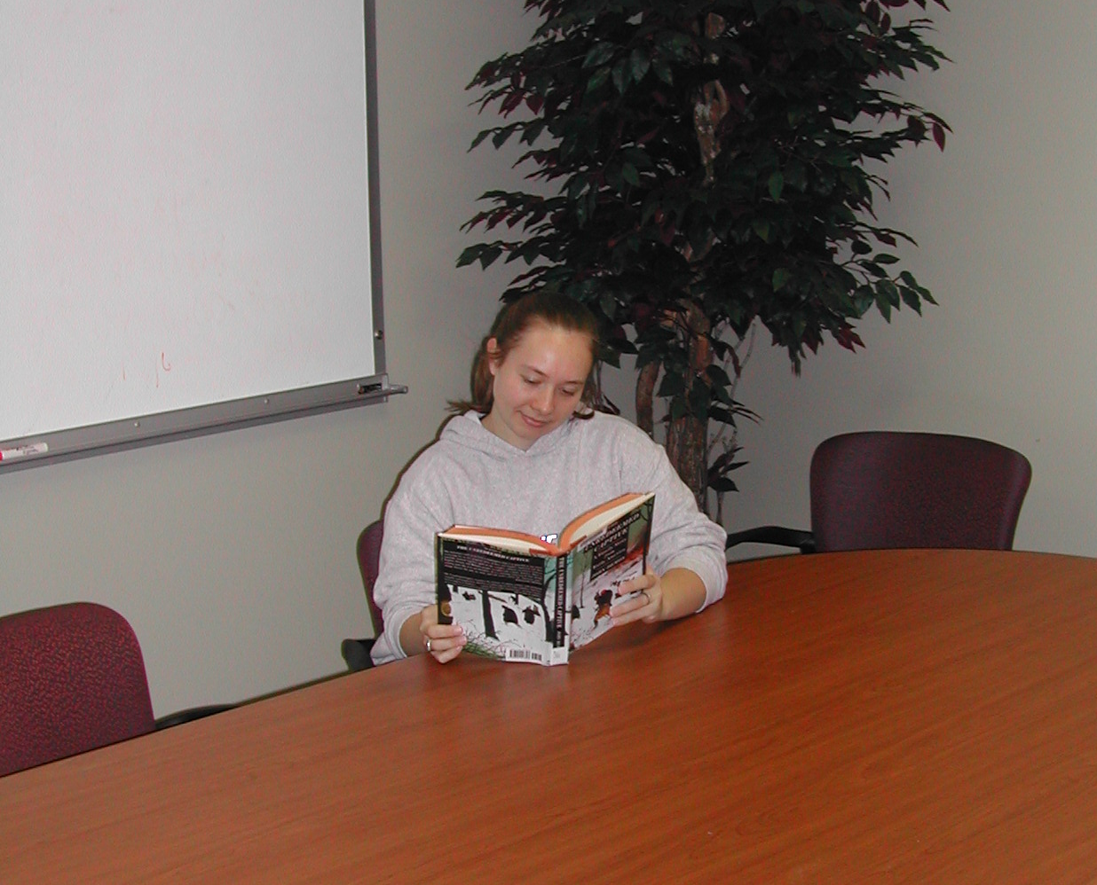

Library Spaces and Places

If you have been to the library recently, I’m sure you’ve noticed some big changes!

The reference/information desk is in a new location, more visible and accessible when you walk in the front door. In the nearby Reference Room, renovations have almost been completed--including the addition of comfortable seating areas and computer tables (with electricity for laptops).

As you go upstairs you will notice new stairwell carpeting, and you will most likely see students working at the new computer tables on the second floor. And if you take a walk around the core of the second or third floors, you will be sure to spot our four beautifully redecorated group study rooms. These accommodate 2-6 people, and are perfect for students working on group assignments, or for faculty who would like a location to meet with a small group. Right now, use of the rooms is on a first come, first served basis.

You will also find a few bean bag chairs for students looking for a comfortable, moveable seat. Combine a bean bag chair with a laptop desk and a laptop computer (both available for sign out from the Circulation Desk), and you’re ready to go!

Finally, we have expanded our browsing collection of popular reading material in the main lobby of Penfield, and are now displaying both CDs and video and DVD programs available for loan in our Periodicals area on floor 2. Our Serials Librarian also moved current issues of our most popular paper journals to create a journal browsing collection in the large reading area to the west of the Periodicals desk. Last, but certainly not least, don’t forget the “Lake Effect Café,” which offers comfortable seating, Starbuck’s coffee, and wireless internet access.

We hope that both faculty and students find our improved spaces to be inviting and comfortable. Please stop by and take a look, or ask for a tour if you’d like!

Barbara Shaffer

Blogging at the Library

Do you know the term “blog?” Blog is short for web-log, a website with immediate updates and information. Some blogs are personal, some are professional. Your library has been experimenting with blogging for the past year. We have covered everything from new resources in the building, to changes in our scheduling, to humor, and the like. Drop by the Library's home page, and look under the “Library News” heading for a link to the Penfield Library Blog. Later this semester we are going to be sponsoring a “Name the Blog Contest,” with prizes for the winning submission. Take a look, tell us what you think, and drop us some ideas for a clever name. We hope to hear from you!
Drew Urbanek

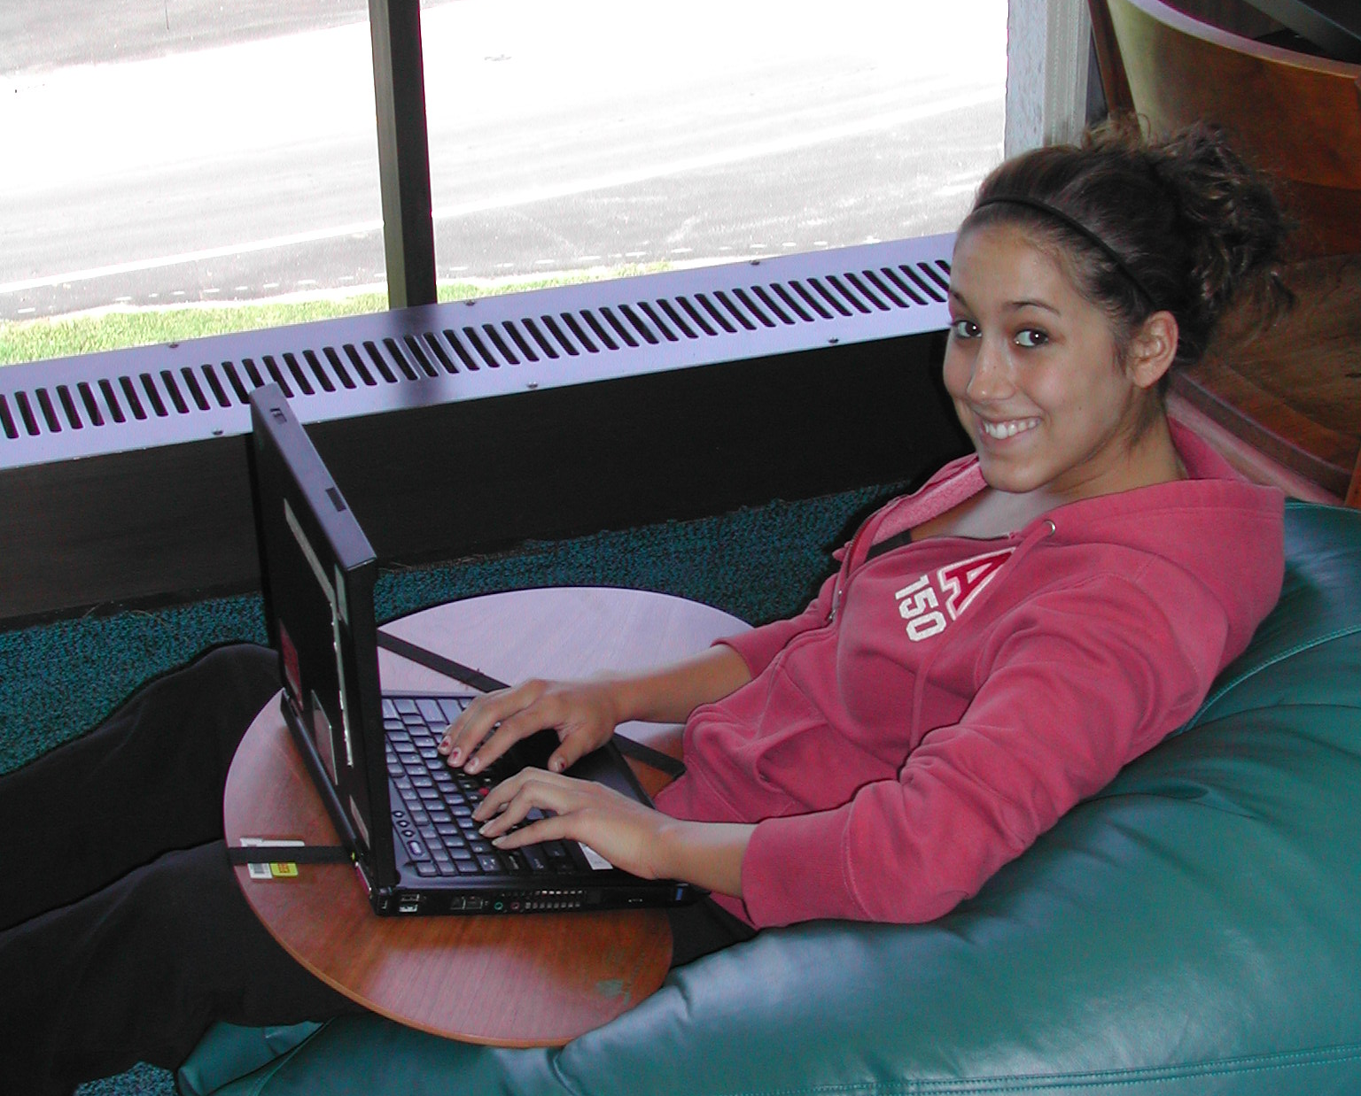

Want to Chat?

Last year’s chat (instant messaging) pilot went well, so it will now be an ongoing service. This means that students and faculty can ask questions of Reference librarians by IM using AOL, MSN, or Yahoo, using our screen name, askpenfield.

We need your help in promoting this as a reference option. So please tell your friends about this new service, and direct them to our “Ask A Librarian” page, linked from the Library’s home page, for chat hours and other contact information.

Barbara Shaffer


Federated Searching
with Central Search

Libraries are continually trying to make the process of gathering information more powerful, easier, and more transparent. One way to do this is to enable researchers to perform one search over multiple databases at the same time. This process, called “federated searching,” is now available to the SUNY Oswego community through a new product called “Central Search.”

Over the summer Penfield staff members were busy, behind the scenes, setting up Central Search to work with some of the more than one hundred electronic products we offer. Initially, Central Search contained the “core” databases from each of our online subject guides, but we were able to add the Library Catalog to the group of searchable databases in September. This will allow you to find both books and articles with a single search.

Central Search will bring more changes to the library’s web site as well. We hope to offer the ability to execute a search for articles and books from a search box on the library’s homepage. So look for the Central Search words and logo and try it out. We welcome your comments on this exciting new resource.
Tom Larson

Did you know? Library Catalog Trivia

You probably already know that the library catalog is the way to find books, videos, DVDs, CDs, and journal titles the library owns. But did you know…

- The New Books & Media in Penfield link on the opening catalog screen will show you titles recently added to the library collection?

- The Renew Books / Sign-in / View Personal Circulation Information link at the top of the catalog pages will allow you to do just that?

- That after you do a search you can click on the Filter link (above the search results) and then select the Available records link to restrict your search to items not checked out?

- That from the Advanced Search screen you can enter your search at the top, then in the Limit by Document Type drop-down menu select Internet Resource, to provide you with a list of electronic, internet-based resources?

Give it a try!

Natalie Sturr

New People in Penfield

The Penfield Library team has some new faces! Please meet our three “new kids on the block:”

Our new Reserves Clerk in Access Services is Deborah Thomas. She joined us this summer after having worked in Parking and OLS for almost four years. Her responsibilities include managing course reserves, including electronic reserves, and supervising student workers in the evening.

Emily Hart was recently hired as our new Reference and Special Instruction Librarian. She comes to us from Daniel A. Reed Library, SUNY Fredonia, where she was Reference, Instruction, and Web Services Librarian.

Aside from her reference and instruction duties here, she will also be organizing the library’s involvement in events like orientation and other initiatives that promote campus and community outreach. Emily will also serve as the library’s liaison to the Department of Communication Studies. She received her B.A. in English from St. Bonaventure and her Master of Library & Information Science degree from the University at Buffalo. She also holds an Advanced Education Technology Certificate from Buffalo.

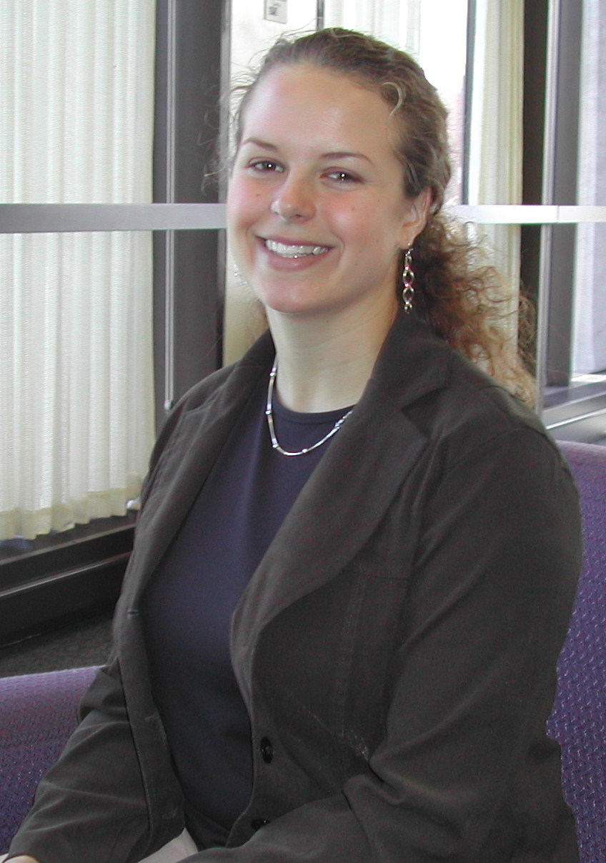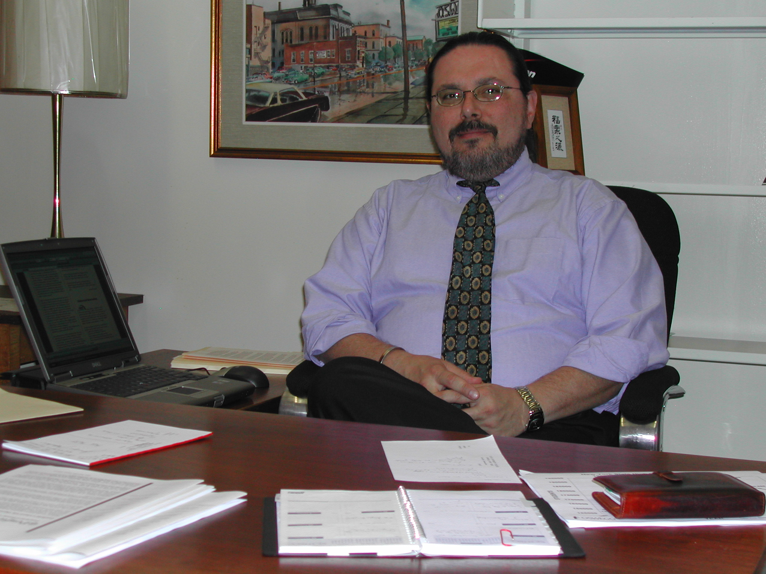

Emily Hart David Clendinning

David Clendinning is joining Penfield as Associate Library Director. David was for many years Head of Reference and Research Services at Strozier Library, the main library of Florida State University in Tallahassee. David received his B.A. with Honors in English and History from Samford University and an M.S. in Library Service from Columbia University. Mr. Clendinning’s responsibilities will include administration of public services in the Library, including Reference, Library Instruction/Information Literacy, Circulation/ Reserves, Interlibrary Loan and Government Documents. He will also serve as liaison librarian to the Department of Modern Languages. David has a daughter entering her third year at the University of Chicago. If you ever hear bagpipes emanating from the library, he is likely the culprit.


Universal Borrowing

The SUNYConnect Union Catalog, available as a link from the Penfield Library Catalog, shows materials owned by all of the SUNY libraries. We encourage you to try this catalog to check if a title you need is owned by another SUNY library. SUNY libraries will be working hard to try to deliver your requested materials within 3-4 business days.

To place a request for material you would like to borrow, from the SUNYConnect Union Catalog:

• Search for the material you need
• Click on the red REQUEST ITEM link
• Select Oswego from the drop-down box
• Click on “Send Request to Oswego Library” link
• Click on the red GO button to interlibrary loan
the request
• Fill in your ILLiad user name and password and
click on the login button
• Scroll down. Click on the Submit Request button.

Of course, if you don’t find what you need in the SUNYConnect catalog, don’t forget to try WorldCat, a combined catalog of millions of items from libraries worldwide. If you have any questions about how to use WorldCat, the SUNYConnect union catalog, the Penfield catalog, or the ILLiad interlibrary loan system, please stop by the Information desk at Penfield Library or contact us via any of the contact methods linked to the Library’s home page. We will be happy to assist you!

Michelle Parry

Web of Science and Citation Searching

Some faculty members have asked if the library subscribes to or plans to subscribe to The Web of Science. For those of you who are not familiar with Web of Science, it is a research tool that combines several databases: Science Citation Index, Social Sciences Citation Index, and Arts & Humanities Citation Index. These databases are not only known for indexing a broad range of the scholarly journal literature but also for providing the ability to search by cited reference. You can quickly retrieve information about who is citing a particular article or author, including yourself.

While the library has found it prohibitively expensive to subscribe to Web of Science at this time, we want you to know that we do have access to the three citation

databases included in it. Arts & Humanities Citation Index is available via FirstSearch. It is linked from our A-Z List of Databases page and from several of our Arts and Humanities subject guides. Access to the Social Sciences Citation Index and the Science Citation Index is available through one of our librarians, who will be happy to perform a search with you or for you. If you wish, you may simply email the citation(s) you want searched via our “Ask a Librarian” link off of the Library’s homepage. These databases are available to student researchers as well.

Beyond these three citation databases there are other resources we provide for citation searching. Several of our EBSCO databases include a cited references search feature: Academic Search Premier; Library, Information Science & Technology Abstracts; PsycInfo; Business Source Premier; CINAHL; and Education Research Complete. For those of you in the sciences try Science Direct and Mathematical Reviews. And don’t forget Google Scholar--citations retrieved in Google Scholar often have links to other publications that cite that work.

Chris Hebblethwaite

Penfield Library #17

CAMPUS MAIL

