Contribute to the Quest Collection in the

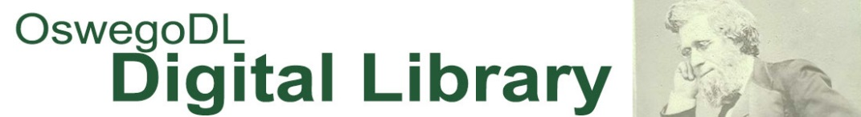

What is the Quest Collection in the OswegoDL?
The Quest Collection is a digital repository to collect, preserve, and disseminate the scholarly, research, and creative production of students participating in the annual SUNY Oswego Quest Program. This collection is housed in the College-wide SUNY Oswego Institutional Repository (Oswego IR), which is part of the SUNY Oswego Digital Library (OswegoDL) housing historical resources and the variety of work done at the College.

What do we want to do?
We want to make your Quest presentation more visible and accessible by including it in the online, searchable Oswego IR Quest Collection.

What is included in the Quest Collection?
Your basic presentation or poster session information is already in the Oswego IR and we will add abstracts for each item in the next month. We will also post the program for this year’s event along with programs from previous years for the official Quest Collection launch in May.
What can you contribute?
We are asking that you to consider providing additional content for your Quest Collection presentation record. This content is an item related to your presentation or poster session that you choose to share with the world. Your contribution to the Oswego IR may be:
- PowerPoint slide of your poster session
- Submitted paper of your presentation
- Outline of your presentation
- Images, video, or audio of you presenting
- Datasets or other supplemental information of/about your research
- Other digital files (including multimedia) associated with your research that you want to share with the world

What are some benefits to contributing your digital item to the Quest Collection?
- Your work is more visible and searchable online.
- There is a permanent record of your program at Quest (a permanent URL will be created).
- You can review statistics on downloads and views of your item.
- You will have ways to link to and see other participants from your year of presentation.

How do I add my content?
To submit, please complete the SUNY Oswego Quest Program release form and return it to Denise Dirienzo, SUNY Oswego Quest Coordinator (145N Marano Campus Center), with your digital files (e.g. PDF, image, multimedia formats) by April 29, 2016. The database will be available on May 6, 2016. For more information about OswegoDL, please contact librarydirector@oswego.edu.

